1. Draw the UML Diagram for Online Voting System, Online Voting is simple, attractive and easy to use. It reduces manual efforts and bulk of information can be handled easily. System should provide concrete security features like creating users and assigning privileges to users of the system. System should be capable of keeping track of all the detailed descriptions of the client and the whole details of services offered by the client organization. Draw the Use case diagram, Class diagram, Activity diagram and Sequence diagram for Online Voting System.

**Solution:**

**Class Diagram:**

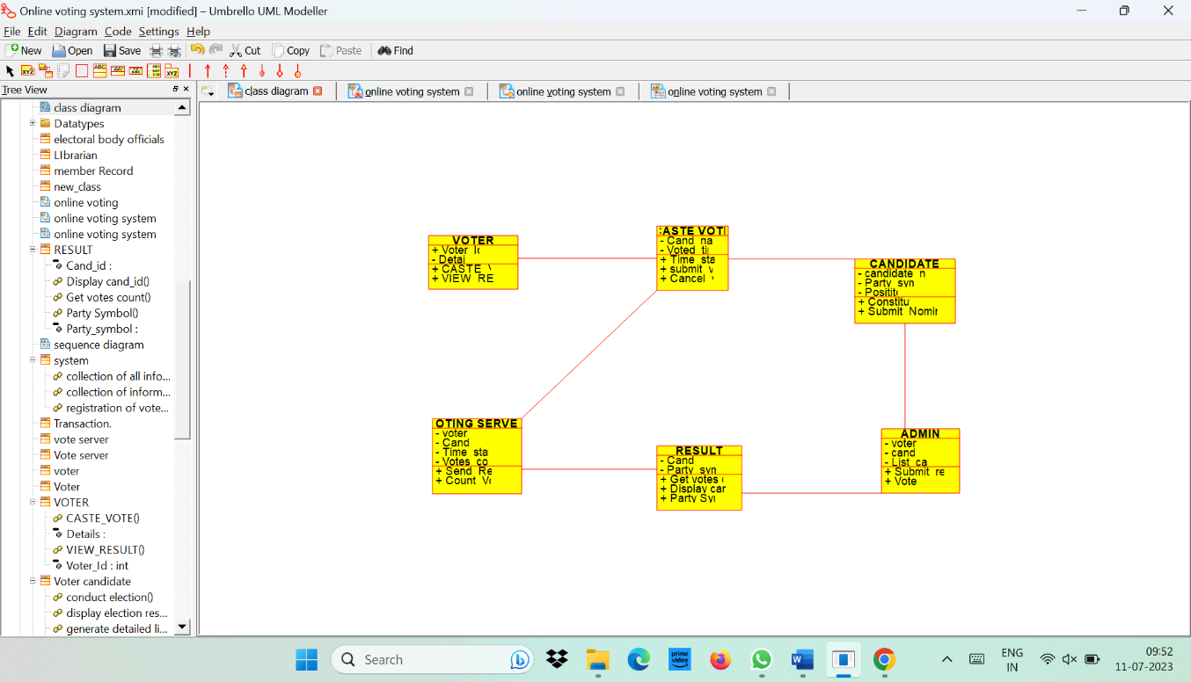

**Usecase Diagram:**

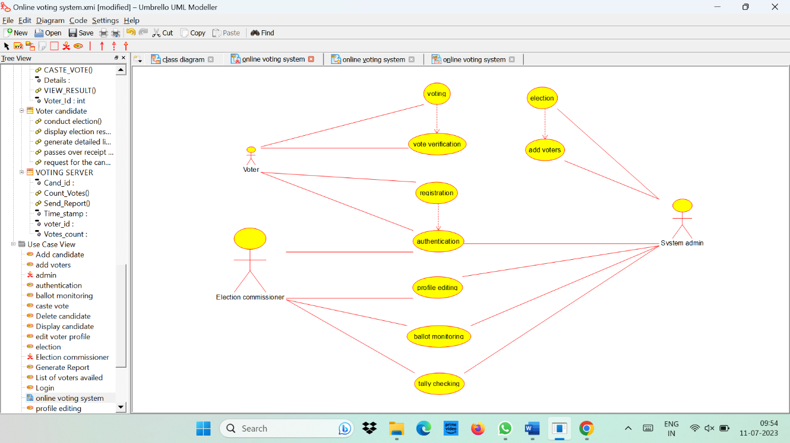

**Activity Diagram:**

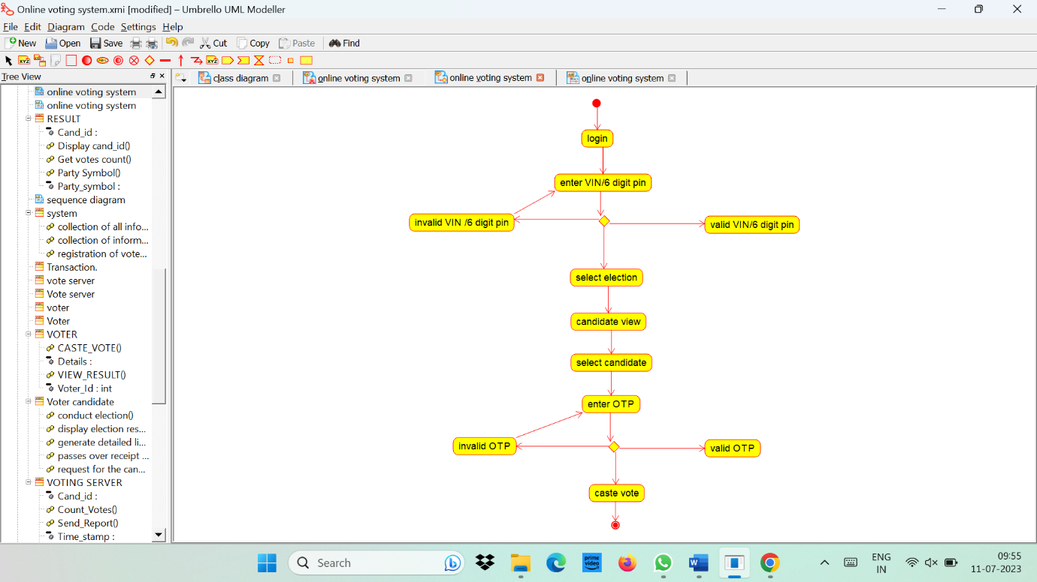

**Sequence Diagram:**

